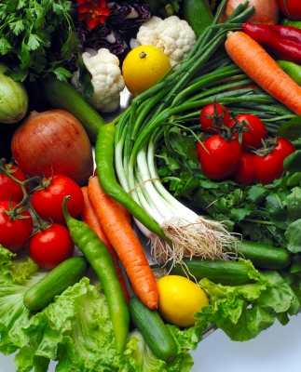
York Organic Gardeners Association
Annual
‘Taste and Flavour’
Fruit and Vegetable Show

photo credit: Suat Eman

Come and Celebrate Local Organic Produce
Saturday 22 September 2018
Brunswick Organic Nursery,
Appleton Road, Bishopthorpe, York

Judging is based on taste and flavour
NOT size or appearance
10.00 – 12 noon Exhibitor Entries
12.00 – 2.00 Exhibition Hall closed for judging
Brunswick café open for lunches
2.00 – 3.00 Public Viewing
3.00 – 4.00 Prizegiving and Open Tasting

Entries from Non-members who grow without sprays very welcome
Just bring entries between 10 and 12 on the day
25p per entry and lots of prizes
Free public viewing – come and taste the entries after judging
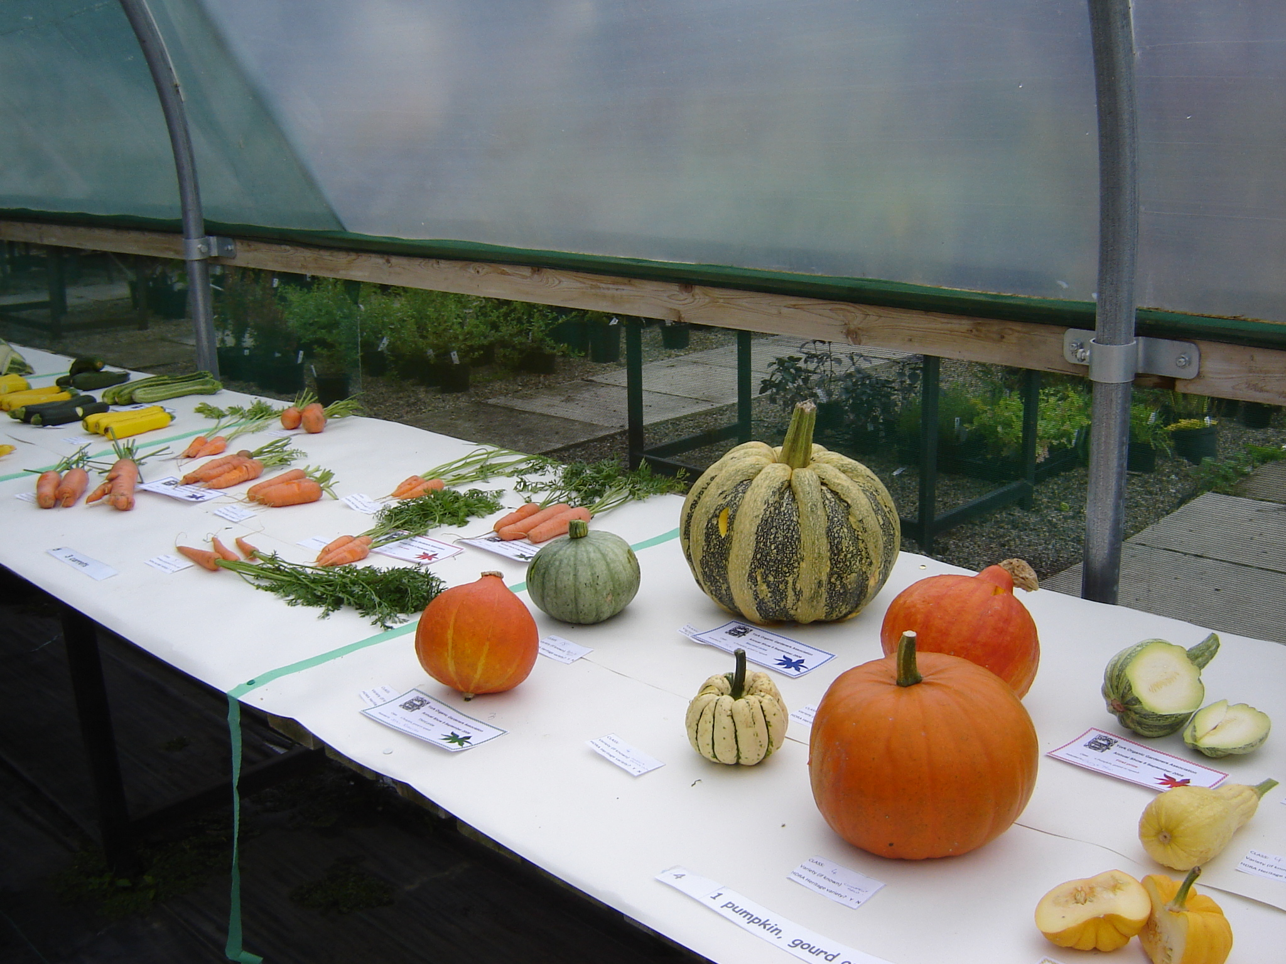

Schedule at: www.yorkorganicgardenersassociation.org.uk
More info: 01904-781691

