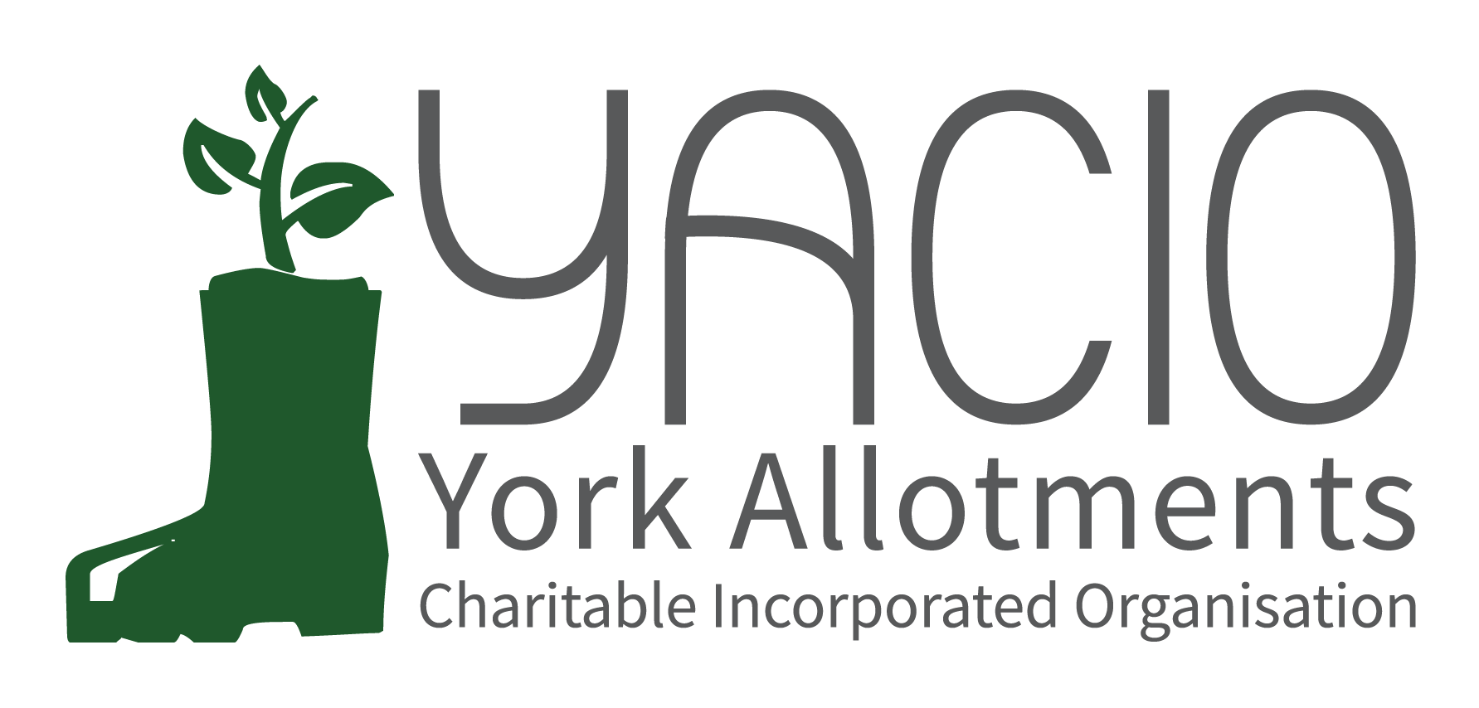
YACIO Site Secretary Meeting
10th October 2022
Attending: Tony Chalcraft [TC], Helen Butt[HB](Holgate), Lisa Turner [LT](Wigginton Terrace), Adam Myers [AM], Heather Whittaker [HW], Helen Butt [HB] Colin Smith[CS], Anna Pawlow [AP], David Brinklow (Hempland), Claire Pickard (Scarcroft), Jane Thurlow (Carr), Sarah Penn (Hospital Field), Dean Fawcett (Howe Hill), Janet Cordingley (Fulford Cross)

Chair: Tony Chalcraft
Minutes: Anna Pawlow
- Welcome
TC welcomed everyone to the meeting and asked everyone to introduce themselves and the site they represented.
- Apologies
John Shirbon (Strensall), Sarah Daniel (Wigginton Road), Robyn Brown (New Lane), Graham Sanderson (Scarcroft), Warwick Ivel (Bootham), Phil Renshaw (Bootham), Sarah Harrison (Low Moor), Efro Tooms (Glen)
- Trustees’ Report
TC noted that tere was a lot to get through this evening with some big topics for discussion. He noted that Trustees hoped to be able to have a review meeting with Dave Meigh before the end of the year but that scheduling was proving difficult. This would be the opportunity to discuss the future beyond the end of the Lease in 2024 and plan ahead.
He reported that HB had taken on the role of Secretary now allowing CS to focus purely on the maintenance work and everyone expressed their gratitude to CS for all of his hard work over the years.
He noted that several issues with finance were due to be discussed later in the agenda.
He reported that a meeting between Trustees and Rachael Maskell MP had taken place in the summer following on from correspondence in the year before. It was a useful meeting and Trustees had the impression that she was supportive and sympathetic towards the allotments and YACIO.
There was an AGM planed for the spring in 2023.
TC noted that the newsletter had been much improved by HB’s focus and offered thanks to HB for all of her hard work.
As always a lot of Trustee time was taken up with resolving issues between tenants.
HB noted that Trustees were focused on renewing the insurance cover for the allotments.
- Finance Report
LT gave a brief outline of YACIO’s finances. The projected overspent was on track and a £10-12k overspend was predicted as planned. Tat amount comes from several years of a small surplus building and was not a sustainable spending level. In future years income and expenditure would need to be more closely balanced. Looking to the future there were concerns about rising costs and there may need to be changes made to accommodate this, either by raising rents or lowering spend on maintenance, involving more volunteers, etc. She noted that CS would be discussing more about maintenance issues and asking for views.
She noted that Trustees did not find a rent increase desirable but that if this were to be necessary then this would probably go to an AGM for tenant’s input.
- Maintenance Report
CS thanked Site Secretaries for their feedback on the Contractor and asked them to keep him informed of any visits so that work could be accurately assessed.
CS noted that the survey of trees was ongoing and had begun with the more difficult sites Scarcroft and Low Moor. Health and Safety issues and sunlight on plots were to areas of focus.
He noted that he was undertaking a survey of all taps and water butts. There had been less necessary maintenance on taps this year so it was hoped that previous investment would stand in good stead now. Thank you t all who had assisted in the emergency water butt inspection.
CS noted that the spend on maintenance was the biggest expenditure for YACIO with 2/5ths of the budget being spent on sites. He estimated that with the increased costs next year this could rise to as much as half of YACIO’s spending. Any tree work will need to be funded from the surplus. Trustees wished to get views on how to limit the expenditure on clearance wok and attendees discussed this and their individual approaches to the issue. It was agreed that Trustees should look at ht ematter more closely in light of the feedback and thoughts received and come up with some kind of criteria for Site Secretaries to apply and perhaps give some idea of the costs involved for each piece of work and present this at the next site secretary meeting.
- Administrator’s Report
AP reported that the Site secretary Handbook had been updated and was available on the Site Secretary’s private page of the website. This incorporated the new notice letters introduced at the beginning of the year. Site Secretaries should be able to find guidance on how to carry out all of the normal processes there but encouraged anyone to contact her with questions if they weren’t sure or had unusual situations to deal with.
AP noted that the new system of regular reports all on the same day seemed to be working well with no issues reported to her so this would continue.
There were a few queries regarding the end of tenancy process and specifics were discussed.
She noted that a lot of sites seemed to have established a good pattern for carrying out inspections and that a good response was being seen where regular inspection and notice letters were happening. Site Secretaries discussed their individual approaches and shared ideas. The idea of an informal “buddy system” was suggested so that site secretaries could assist each other and give second opinions. Trustees agreed to consider how this might work.
AP noted that if there was a plot sitting on the vacancies list for a while it was a good idea to inform her and then any approaches to letting it could be assessed. With the current levels of demand plots shouldn’t be sitting unlet for months. The could be offered for free or cleared if necessary.
- Bonfires
- Waterbutts
-BREAK-
- Best Plot Competition
- Reports From Site Secretaries & General Issues Raised
- Any Other Business
None
- Next Meeting
TBC

