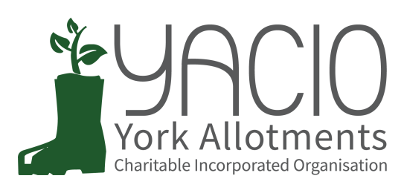
YACIO Trustee Meeting
7th September 2022
Attending: Tony Chalcraft, Anna Pawlow, Helen Butt
Chair: Tony Chalcraft
Minutes: Anna Pawlow

- Apologies
Lisa Turner, Colin Smith, Heather Whittaker, Simon Wild, Adam Myers
- Approval of Minutes
Minutes of the last meeting were approved as a true record.
- Actions
Bootham Complaint - TC updates on the issues and it was agreed that TC & LT should progress as planned.
Action: TC& LT to progress
Wildlife - The meeting of Trustees took placed and it was decided that it was not up to YACIO to impose on sites but to invite tenants and associations to work to implement areas. It was agreed that a survey would be circulated in the upcoming newsletter.
Review Meeting - Action: TC to ask DM for available dates separate to the November Trustee Meeting.
Water Butts - CS to carry out water butt inspection at same time as tap inspection prior to the November meeting. AP to email Site Secretaries asking them to highlight any immediate hazards for prioritisation.
Action: AP to email site secretaries
- Chair’s Report
TC notes that he was n the process of arranging the review meeting with DM. He identified a desire to do more to engage with Associations and Tenants and to improve skills.
- Finance Report / Budget
LT has circulated a finance report by email. It was agreed that the forecasted overspend and the budget needed to be discussed in more detail at the next meeting.
- Secretary Report
HB reported that CS had notified the Charity Commission of the change of Officers and updated her details and that a handover meeting had taken place between CS, AP and HB.
- Administrator Report
AP noted that everything was proceeding as normal for the time of year with nothing of particular note occurring.
- Trustee Reports (Specific Responsibilities)
- Maintenance
The Tree Inspection at Low Moor was proving more complex that originally envisaged and TC would need to discus further with CS on his return.
Action: TC & CS to discuss and progress
- Complaints
No new complaints, 2 existing in progress.
Holgate Termination - No formal appeal forthcoming.
Action: AP to email the tenant confirming the termination is upheld.
- Site Specific Issues
Hosepipes - A query regarding the filling of waterbutts had been received. As no information was present forbidding this it had been decided that so long as the water was for the use on food crops this was allowed. There had been a number of emails from tenants on Hempland where a hosepipe ban had been in force by the Association prior to the Yorkshire Water ban and TC was discussing this with the Association.
- Associations
AM was trying to set up a meeting for all.
- Document Review
N/A
- Website development
HB had contacted MCPC to transfer the hosting of the website before the end of the month. She would follow this up.
HB noted that there were no meeting minutes available for the April Site Secretary Meeting. TC would investigate who had the document.
HB had added an article to the News section about Dobbies now recycling soft plastic such as compost bags.
- Newsletter
The newsletter prepared and circulated by HB was approved.
Action: AP to send to tenants
- Issues Requiring a Decision:
a) Water Butt Height - 75cm agreed and CS to conduct full inspection when inspecting taps.
b) Poster for Hosepipe Ban - No longer needed
c)Accepting New Trustee - Deferred
- Issues for Discussion:
a) Wildlife - Deferred
- Any Other Business
None
- Next Meeting Dates
5th October - Trustee Meeting
10th October - Site Secretary Meeting

