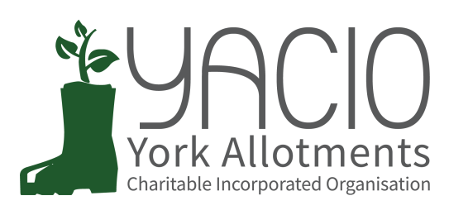
YACIO Trustee Meeting & Review Meeting
7th December 2022
Attending: Tony Chalcraft, Lisa Turner,
Heather Whittaker, Adam Myers, , Helen Butt, Anna Pawlow, Dave Meigh, [Colin Smith]
Chair: Tony Chalcraft
Minutes: Anna Pawlow

Apologies
Simon Wild, Maria Lewington
Welcome
TC invited preliminary comments from DM and DM noted that he had had little involvement as no issues had been brought to his attention and this was a positive. He noted there were still some legacy issues to resolve and the possible extension of the Lease to discuss.
Lease
The extension of the Lease was discussed for a longer term of perhaps 25 years. This would enable more fundraising options to be pursued in the future if the Trustees wished to go down that route. Legacy issues would need to be addressed before the current Lease finishes and a new Lease commences.
Action: Trustees to write to DM and request a 25 year extension to the Lease to be considered.
CS & DM to Liaise regarding outstanding Legacy Issues.
Extra Allotment Provision
Trustees discussed the expanding waiting lists and queried where responsibility for this should lie. DM confirmed that at present there was no prospect for further council land. It was agreed that the issue was a wider issue affecting not just YACIO and that working with other parties would be the only way to take the matter forward in the future.
Insurance
LT had previously raised some issues regarding insurance cover with DM and these issues had been resolved prior to the renewal of Insurance.
Site Shops
Trustees raised the issue of the site shops located on several sites. They were conscious that YACIO had no formal agreements in place regarding these buildings and asked DM for his insight and input on the matter. DM had not found any formal agreements pre-dating YACIO’s management. He would continue to look for any evidence of agreements from the past. The option of granting Licences was discussed and the risks to YACIO of not having formal agreements in place highlighted
Action: DM to clarify position on agreements. Trustees to discuss further.
AOB
Wigginton Road Trees
LT asked for advice regarding how to progress the dangerous trees bordering Wigginton Road Allotments. The situation and various options were discussed.
Action: LT to email details to DM.
LT to contact site secretary. AP to send formal letter to the tenant.
Fulford Cross
Following a tenant request to lock the access to Fulford Cross Trustees sought further clarification on the status of the access. It was agreed that this could be done.
Wigginton Road Car Parking Spaces
It was queried whether there should be one or two spaces allocated to the Allotments in the car park.
Contractor
CS joined the meeting remotely to discuss issues regarding the provision of the maintenance contract. CS proposed ending the contract with the present contractors and witholding payment due to services not being completed. He had gained a quote from a new contractor for next year and he recommended toTrustees that this contract was issued. Trustees discussed the details of the contract and agreed to support CS’s proposal.
Action: CS to finalise contract with new contractors. LT to look at the options for VAT regsitration again.
Concession Policy
With DM in attendance Trustees discussed the proposed amendments to the Concession Policy. It was noted that YACIO faced significant rising costs and it was agreed that the option of adjusting concessions as well as raising rents should be looked at in order to make concessions accessible for those with a genuine need. Trustees discussed the proposed options put forward prior to the meeting and it was agreed that further consideration was necessary.

Next Meeting Dates
15th December - Envelopes
4th January - Trustee Meeting

