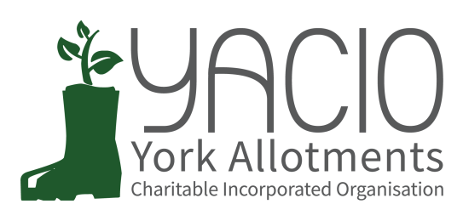
YACIO Trustee Meeting
1st March 2023
Attending: Tony Chalcraft, Lisa Turner, Colin Smith,
Heather Whittaker, Adam Myers, Anna Pawlow
Chair: Tony Chalcraft
Minutes: Anna Pawlow

- Apologies
Helen Butt, Simon Wild, Maria Lewington,
- Approval of Minutes
Minutes of the February meeting were approved as a true record.
- Actions
Workshop Booking Fees - AP to investigate
Savings Account - LT progressing
Site Shop Licences - LT has drafted a Licence for Low Moor based on the original with CYC. This has been approved by the Association so LT will arrange signing.
Action: LT to add to drive (AP to assist if necessary)
AM to progress Bootham/Glen/Hempland
Legacy Issues - CS has reached out to DM to progress but not got anywhere yet.
Action: CS to progress with DM
- Chair’s Report
Nothing to report
- Finance Report / Budget
LT had prepared and circulated the accounts for 2022. Trustees approved these.
LT is predicting a £7000 per month spend this year. Trustees discussed the budget for extra maintenance. It was agreed that only emergency tree work should go ahead at present and then in the summer the plan can be revisited ahead of autumn work after the nesting season.

- Secretary Report
None

- Administrator Report
AP had circulated a report.
Colony - The Colony issue was ongoing and Trustees discussed this. It was agreed that the annual invoice should not be paid until this was resolved. AP should give a deadline for the end of the month for this to be totally resolved.
Telephone Payments - AP reported that Paypal were discontinuing the Paypal Here app that was currently used to take telephone card payments. Alternative services would charge a high fee over that of the value of the payments taken by telephone making this non-viable. It was discussed and agreed that telephone payments should be discontinued and the options for payment going forward would be by cheque or online. AP should keep an eye on demand for an alternative service and whether this would be viable.
- Trustee Reports (Specific Responsibilities)
- Maintenance
CS reported that hedge work had been completed with good feedback from Site Secretaries as to the quality of the work.
- Complaints
None.
- Site Specific Issues
Bootham Termination - AP outlined the issue and it was agreed that TC/LT should become involved if we hear further.
Scarcroft Hazel - AM had visited the site and reported to Trustees on his assessment.
Scarcroft Site Hut - AM had visited site and had a productive meeting
- Associations
AM had arranged a meeting for the end of the month. It was agreed to rent a room at Friargate for this meeting.
e) Document Review
None
f) Website development
None
g) Newsletter
None
- Issues for Discussion
- Concession policy
Trustees discussed the details of what would be proposed at the AGM.
- Site Secretary Meeting Follow Up
Deferred
- AGM
Trustees discussed and agreed the items for the AGM and how to present the proposals regarding concessions.
Actions: TC to draft email/letter for circulation to tenants.
AP to send to all tenants when received.
TC to discuss with HB
- Risk Assessments
Deferred
- Trustee Site Visits
Deferred
- Any Other Business
None

- Next Meeting Dates
23rd March - Association Meeting
25th March - AGM
5th April - Trustee Meeting

