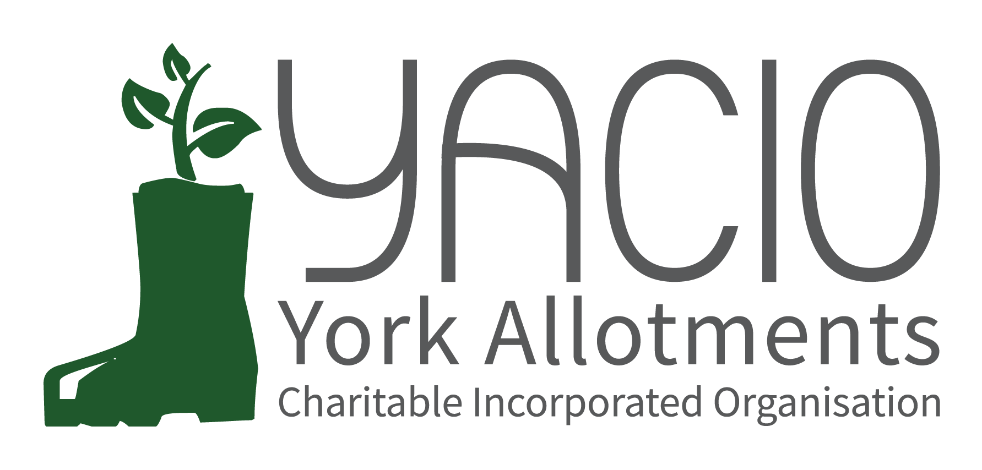
YACIO Site Secretary Meeting
6th February 2023
Attending: Tony Chalcraft [TC], Helen Butt[HB] (Holgate), Lisa Turner [LT](Wigginton Terrace), Adam Myers [AM], Heather Whittaker [HW], Marial Lewington [ML], Colin Smith[CS], Anna Pawlow [AP], Claire Pickard (Scarcroft), Graham Sanderson (Scarcroft) Jane Thurlow (Carr), Sarah Penn (Hospital Field), Dean Fawcett (Howe Hill), Janet Cordingley (Fulford Cross), John Shirbon (Strensall), Mary Harlington (Green Lane),Katherine Lancey (Hob Moor), David Brinklow (Hempland), Warwick Ivel (Bootham)

Chair: Tony Chalcraft
Minutes: Anna Pawlow
- Welcome
TC welcomed everyone to the meeting and asked everyone to introduce themselves and the site they represented.
- Apologies
Sarah Harrison, Adam Myers, Christine Robertson, Phil Renshaw, Colin Smith
- Trustees’ Report
TC reported that Trustees had dedicated a lot of time and thought to the issue of Rent Increases and Concessions, to be discussed later.
The renewal of the Lease was ongoing with DM wishing for YACIO to take the lead in beginning the process. There were still legacy issues to resolve before the new lease.
The fault on Colony had produced a lot of extra work and there had been no option but to approach tenants directly to resolve the queries. TC was happy to report that LT had negotiated a full refund of the annual fees as compensation for this disruption. Trustees were very aware of the cost to the loss of administrator time and to YACIO’s reputation.
The next Newsletter was due to be sent out imminently and a new feature of the website was the new Plotlines blog written by a tenant on a bimonthly basis. TC suggested that if anyone had any ideas or contributions along these lines they should get in touch as Trustees were keen to make better use of the website. Trustees were happy to advertise events or publish write ups of events either in the newsletter or on the blog.
The AGM had gone well with much discussion of the rent increase and concession changes.
Trustees were keeping the weather under review with a possibility of another need for a hosepipe ban and bonfire ban but this was under constant review.
- Finance Report
LT gave an outline review of the position of YACIO’s finances mid year. She noted that there was an increased maintenance spend planned for the winter. She also reported that a new savings account had been opened to enable interest to be accrued on deposits.
- Maintenance Report
CS absent
- Administrator’s Report
AP updated everyone on the Colony issues and the impact that this had had and was likely to have going forwards. This was still likely to take some weeks to resolve.
She thanked site secretaries for their hard work on conducting site inspections and arranging new lets.
- Best Plot Competition
CP and JT updated everyone on the progress for the Best Plot Competition and asked for volunteers for judging which would take place at the beginning of July.
- Concession Policy and Rents
TC thanked site secretaries for their input on the discussions and updated Site Secretaries on the decision reached and the plan for communicating this to Tenants in the next few days. There was a short further discussion of the details and reasoning of the plans. TC stressed to site secretaries that there was no wish to deprive anyone of their allotment and if they were in financial difficulties but not eligible for a concession based on receipt of benefits then there was a hardship fund available.
- Risk Assessments
HW was conducting the 6 month review with tenants to be contacted directly by YACIO and any larger issues addressed by CS. The next review would be November. HW thanked Site secretaries for all of their hard work.
- Site Visits
TC advised that Trustees intended to make site visits to all sites and that they would be in touch to arrange these.
- New Lease
TC noted that discussion of the renewal of the Lease were underway with CYC and that a likely term would be 25 years. He asked that if Site Secretaries had any input on issues to please get in touch.
- Reports From Site Secretaries & General Issues Raised
There was a general discussion of site specific issues including issues with bee swarms, break ins on allotments, further development of community plots on sites and water pipe access issues.
TC reminded everyone of the current hosepipe use o=policy.
- Any Other Business
None
- Next Meeting
16th October - TBC

