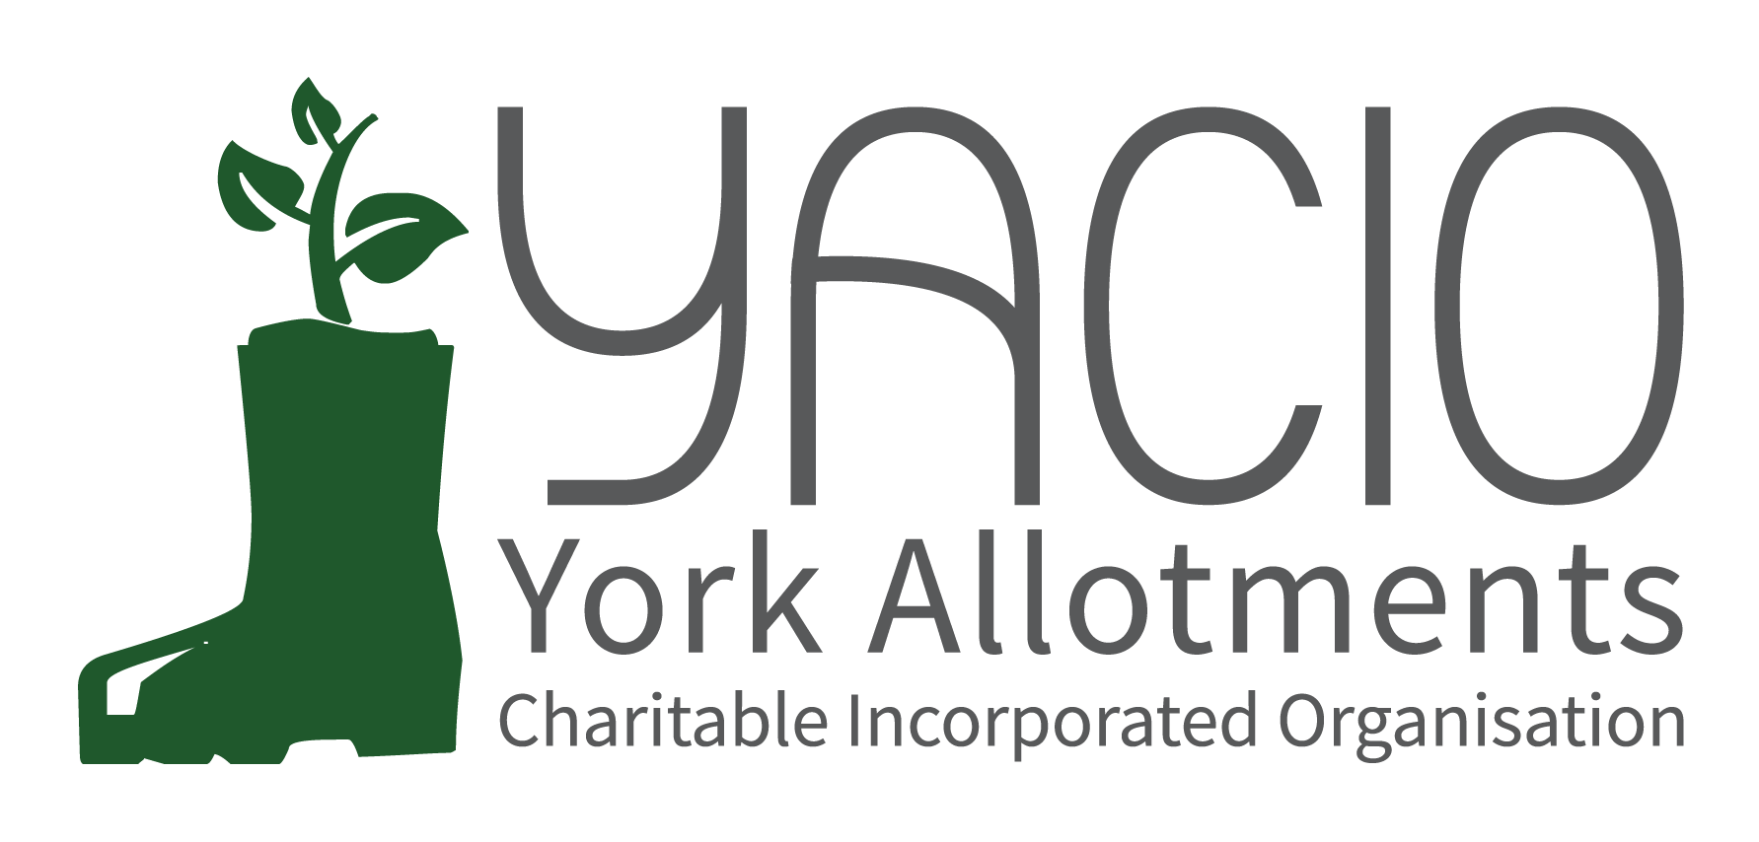
YACIO Site Secretary Meeting
16th October 2023
Attending: Tony Chalcraft [TC], Helen Butt[HB] (Holgate), Lisa Turner [LT](Wigginton Terrace), Adam Myers [AM], Colin Smith[CS], Anna Pawlow [AP], Claire Pickard (Scarcroft), Graham Sanderson (Scarcroft) Norah Godfrey (Glen), Sarah Penn (Hospital Field), Dean Fawcett (Howe Hill), Janet Cordingley (Fulford Cross), Mary Harlington (Green Lane), David Brinklow (Hempland), Warwick Ivel (Bootham), Phil Renshaw (Bootham),

Chair: Tony Chalcraft
Minutes: Anna Pawlow
- Welcome
TC welcomed everyone to the meeting and asked everyone to introduce themselves and the site they represented.
- Apologies
Heather Whittaker, Maria Lewington, Jane Thurlow (Carr), John Shirbon (Strensall), Katherine Lancey (Hob moor), Christing Robertson (Low Moor), Sarah Harrison (Low Moor), Simon Wild
- Trustees’ Report
Lease - TC reported that the Trustees continued the renewal of thre Lease negotiations. The existing Lease ends in November 2024 so there was a year to get this finalised. There was every reason to believ that this would be done and for the longer term of 25 years. There were some queries to resolve regarding boundary issues for the plans and the priority was to resolve these before the new Lease came in.
Changes to Rents and Concessions - AP had written to all tenants in receipt of a concession explaining the new rules and inviting them to apply for the year ahead. There were still a small number of unhappy tenants and Trustees were endeavouring to respond to all to explain the situation. It was anticipated that the receipt of the new invoices in the new year would result in more issues to address from unhapppy tenants. TC outlined the new criteria and the new amounts of rent fro those present. The key change is that no further age based concessions will be grated, only means tested concessions.
Q - A query was raised regarding making changes to the rents and the legal position. TC confirmed that all changes had been made in accordance with the constitution and guiding vote had been in support at the AGM.
New Site - There was the possibility of YACIO taking over the running of an allotment site in Heslington and discussions regarding this were at an early stage but Trustees were keen to expand the allotments available. Trustees felt strongly that this should be funded from external sources and not from existing revenue from YACIO rents.
Garden Share - CYC’s Home Share Scheme was considering a similar sccheme for gardens and Trustees had been in discussion with the officer responsible as to how that might work. This would be as a preliminary to, not an alternative to an allotment.
Newsletter - The newsletters continued to be produced quarterly by HB and she was also responsible for the website updates.
Trustee Vacancy - TC noted that there was still one vacancy on the board to fill. He also noted that if someone did not want to join as a full Trustee there was still the option to assist on special projects.
Funding - TC commented that with the increasing uncertainty regarding CYC funding and as such ward funding may no longer be available in the future. Any larger projects may have to look for alternative means of external funding in the future and this was something to be mindful of.
- Finance Report
LT outlined the financial position. YACIO accounts were in a good position with an anticipated increased outlay on maintenance in the final quarter to allow for some extensive tree work and hedge maintenance to take place. This would bring in line with the budgeted overspend but still retain a comfortable surplus ion the reserve. LT noted that costs continued to increase due to inflation and that the coming rent increase would help to insulate YACIO against this moving forwards.
- Maintenance Report
CS noted that maintenance work continued to get busier and busier and that this was positive as it meant that maintenance was being continuously carried out and improvements made. He thanked Site Secretaries for their hard work and assistance in these matters. Hedges would be a major priority this winter and looking ahead to next year addressing neglected and unlettable plots would be a priority to try to maximise use of existing resources. CS welcomed any feedback on the work of the contractors. It was their first year and that was always a learning curve. He hoped to move in the coming year in a good position.
- Administrator’s Report
AP thanked Site secretaries for their hard work and noted that site inspections had increased this year which was helping to get neglected plots turned around quickly now and this was encouraging.
AP outlined a few housekeeping issues.
Waiting List - When an applicant from the waiting list takes on a plot on any site their name is automatically removed from the other waiting lists that they may be n. If they would like to remain on the list for a different site then this needed to be indicated at the time of taking on the plot so they were not automatically removed.
Notice Letters - There was no need to start from Letter 1 every time if an inspection in the middle had taken place but no letter sent the Letter 2 could still be sent the next time if necessary. It was also possible to start straight from Letter 2 if there was a history of non-culitvation and this was a persistent issue. Site Secretaries should specify that this is what they wish to do.
Terminations - If a tenant notifies you they are terminating their tenancy please inform us as soon as possible as we cannot process a termination and new let at the same time, there’s a notice period that has to be observed.
Q - A question was raised about actions in the event of a tenant’s death. TC read out the relevant clause from the tenancy agreement.
Q- A question was raised about actions in the event of a tenant going into a nursing home. TC noted that there was no current policy but something similar to a tenant’s death was probably the best course of action. Trustees would discuss this and agree a policy.
Q - Should applicants be asked to resubmit their application each year? AP noted that this would not be possible within the current systems.
Q - A query was raised regarding tenants with more than one plot. AP noted that this had historically been allowed but that current policy was that no tenant should be granted more than one full sized allotment at present. Legacy holdings would be honoured.
Q - A query was raised regarding the telephone system and whether they were real people. AP confirmed that they were real people but followed a script and English might not be their native language. This ensured that calls would be answered 24/7 and basic queries could be dealt with without involving the administrator. She noted that there were flaws to the current system but that at present it was the best solution available given limited administrator hours.
- Repeat Non Cultivation
HB outlined the issue of persisten non-cultivation resulting in multiple Letter 1s and asked for thoughts. A discussion took place among attendees and it was agreed that a standard system would be welcomed and Trustees would draft a policy for trial in the year ahead.
- Hedges
CS outlined the position regarding hedge work. YACIO had offered assistance to tenants who were unable to get their own hedge cut down to 1.5m winter height. Where the hedge was an inherited problem then YACIO would fund this as a one off but if the tenants had allowed the hedge to grow beyond control then they would be asked to contribute most if not all of the cost of YACIO doing the work.
CS noted that where possible if a plot had a hedge that was over 1.5m this should be cut back by YACIO before being relet. The issues with timing were noted as this could only take place outside of the nesting season.
CS also raised the question of expanding the use of dead hedges and communal compost heaps to decrease the amount of green waste removed from sites and asked for Site Secretaries to consider these options for future discussion. MH volunteered to set up a talk from an expert composter on Green Lane who manages their communal compost heaps next summer.
- Reports From Site Secretaries & General Issues Raised
Site Secretaries went around the room and gave a brief update on their sites and any issues they were facing.
- Any Other Business
None
- Next Meeting
February 2024 - TBC
July 2024 - TBC
October 2024 - TBC

