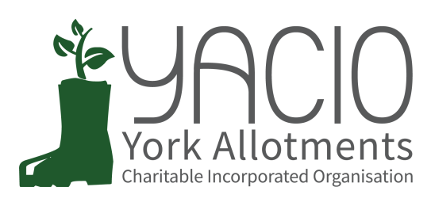
YACIO Trustee Meeting
4th October 2023
Attending: Lisa Turner, Helen Butt,
Colin Smith, Simon Wild, Heather Whittaker, Anna Pawlow
Minutes: Anna Pawlow

- Apologies
Tony Chalcraft, Adam Myers, Maria Lewington
- Approval of Minutes
Minutes of the September meeting were approved as a true record.
- Actions
Site Visits - TC to arrange schedule of visits
Domestic Garden Assistance - TC to follow up
Heslington Allotments - TC to follow up
Insurance - LT to follow up
All actions were reported as completed or in progress.
- Chair’s Report
TC had circulated a report buy email in his absence.

- Finance Report / Budget
LT had circulated a brief report. The position with regards to the maintenance spend was now clearer and CS was to move forward with arranging works before the end of the year.

- Secretary Report
HB had prepared a report and circulated it. HB reported that she and AP had had their usual meeting and had no unusual issues to report. HB had set up an account for online access to the Charity Commission website. Her work had revealed some issues that would need resolving regarding YACIO web policies. A cookie warning and a social medial policy would need to be arranged. HB suggested a folder on the shared drive for policy documents to be held in in addition to the manual compiling all policies.

- Administrator Report
AP had circulated a brief report. There were no unusual issues to report.

- Trustee Reports (Specific Responsibilities)
- Maintenance
CS had obtained quotes for all of the maintenance work projected fo this quarter and this totalled £23000. Trustees discussed some site specific issues and how projects should be prioritised. It was agreed that projects where this would deliver extra lettable space the fastest would be given priority at this juncture.
Lengthy discussion about the project on Low Moor and the logistics involved took place. It was agreed that CS should involve the site secretaries as soon as possible and arrange making contact with the tenants as a priority.
CS noted that the contractors and handyman were predicting increases in their rates next year. Details should be available for the next meeting for consideration.
Action: CS to contact Low Moor SS and arrange contact with tenants to be affected
HB to obtain 3 quotes for tree work on Holgate
Complaints
ML had dealt with several termination appeals.
- Site Specific Issues
TC circulated a written report in his absence.

- Associations
AM held and Association meeting on 9th September. Attendance was good. HW gave a brief update on the discussions.
e) Document Review
Action: SW to update the Site Secretary Handbook. HB to publish on website when approved.
f) Website development
HB flagged the need for a cookie policy and had added a link to the Privacy Policy form all pages of the website. The rent and concession costs were in the process of being updated
Action: HB to investigate what is needed for website compliance and responsibilities.
AP to ensure concessions in application section are updated.
g) Newsletter
HB asking for suggestions for the January newsletter (to be finalised by the beginning of December).
Action: HB to come up with a list of items.
- Issues for Decision
- Site Secretary Meeting Agenda - Trustees discussed and agreed the Site Secretary Meeting Agenda.
Action: AP to circulate the agenda.
LT to draft proposal for repeat non cultivation policy.
LT to draft feedback form.
- Site Visits - In progress
Action: CS to mark up the plans in advance and circulate to Trustees for consideration for the Lease.
HW to amalgamate site visits with the Risk Assessment visits where possible.

Issues for Discussion
a. First Aid Kits - Trustees discussed the request for First Aid Kits to be provided on site and agreed that this was not within YACIO’s responsibilities and that the risk was too great. Tenants should be responsible for their own well-being on site.
b. Hedges - Trustees discussed criteria for granting assistance with hedge cutting. It was agreed that if it was an inherited problem then a one of cut would be done at YACIO’s cost. If the tenants had allowed the hedges to grow beyond their scope then the should be responsible for the costs.
- Any Other Business
Dead Hedging / Communal Compost - CS wanted to gain opinions on the option of increasing the use of dead hedges and communal compost heaps on sites to minimise the amount of green waste removed from sites. There were both ecological and financial costs to doing so and he felt that options fr keeping green waste on site would be beneficial. Trustees discussed this.
Action: CS to prepare a paper on this and bring for further discussion in the new year.
Waiting List Checks - CS querying whether all tenants on the waiting lists should be contacted and asked if they wish to remain on the list. AP noted that this was done on an ad hoc basis for individual sites but processing the responses from a bulk email to all applicants at once would result in a large amount of admin work to process the responses.
Lease - Action: Trustees to give LT feedback by email for compilation before the next meeting.
- Next Meeting Dates
16th October - Site Secretary Meeting
1st November - Trustee Meeting

